Case 5-Asia-China-Shang-Alligator with Muntjak Deer Horns-Bronze-1500 BCE

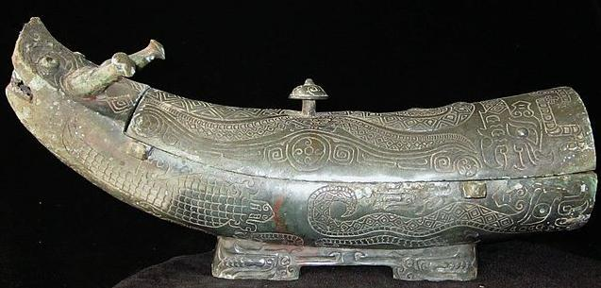
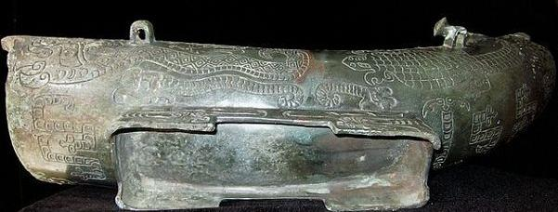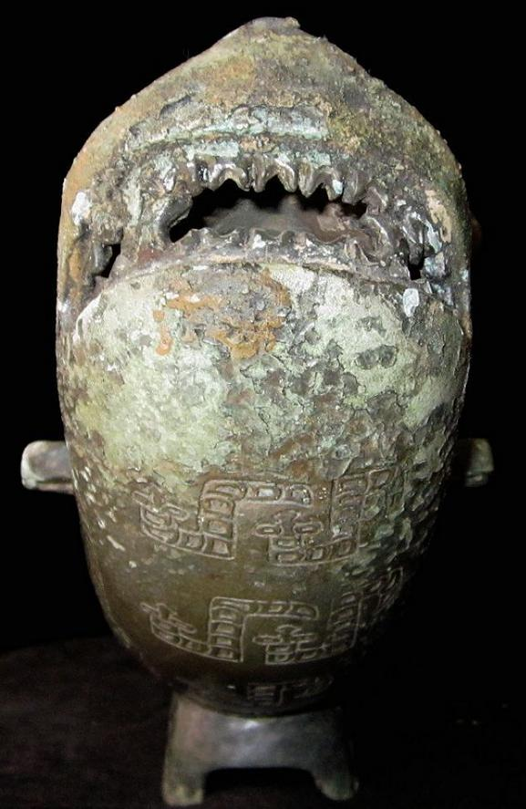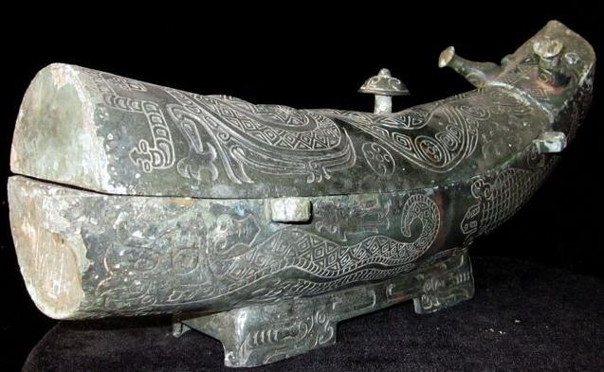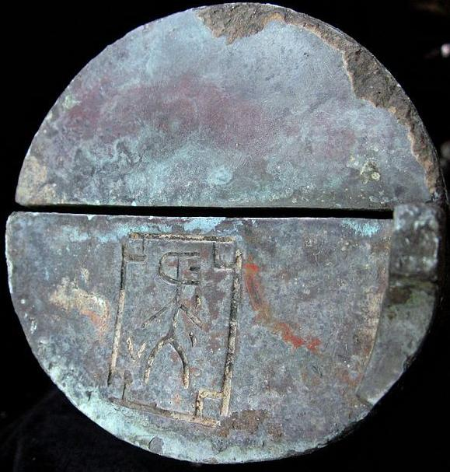
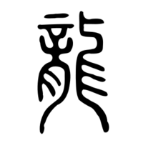
The ancient seal script form of the character for "dragon" that is now written 龍 or 龙 and pronounced lóng in Mandarin. Traditional Kangxi Radical 212) in the Shuowen seal script
After http://hanziyuan.net/#%E9%BE%8D
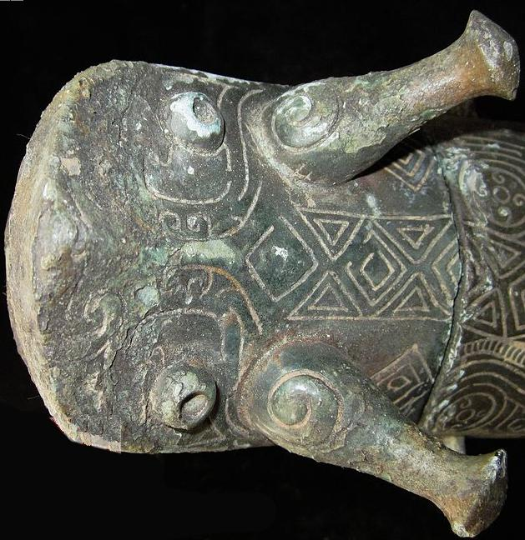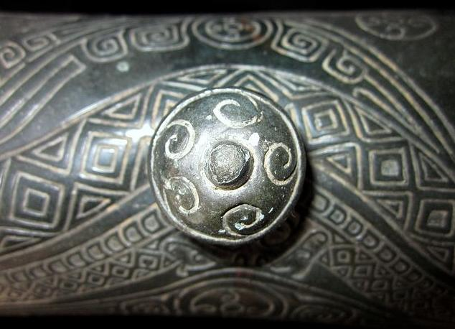
Water wave carvings on knob with diamond reptilian skin pattern of snakes on lid.
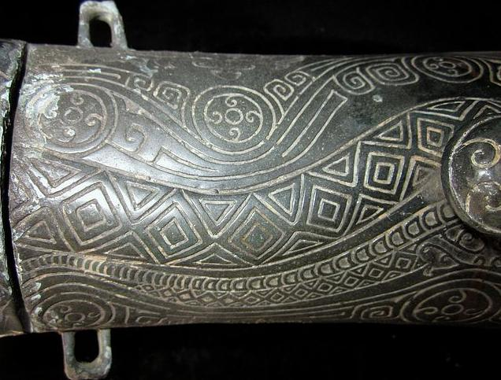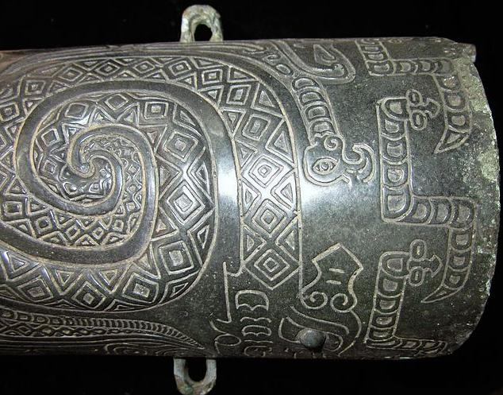
4Rings on the body, which was used for connecting the rope and body..
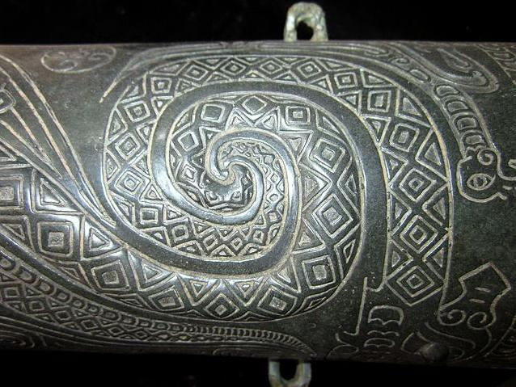
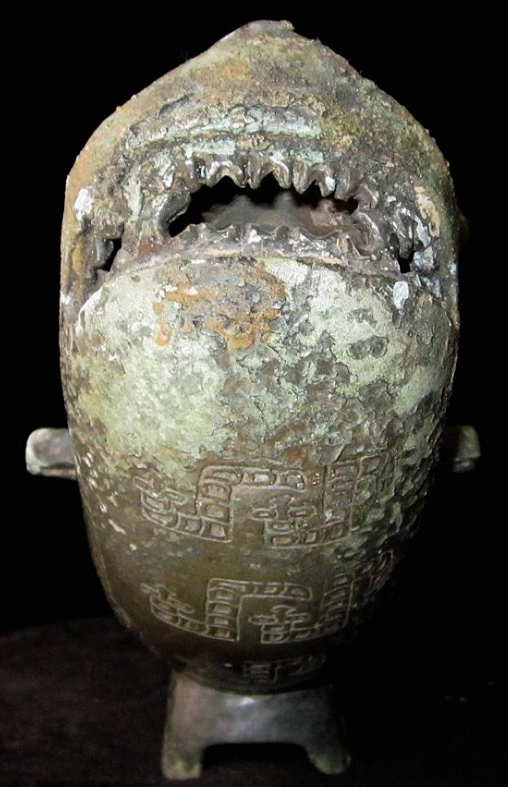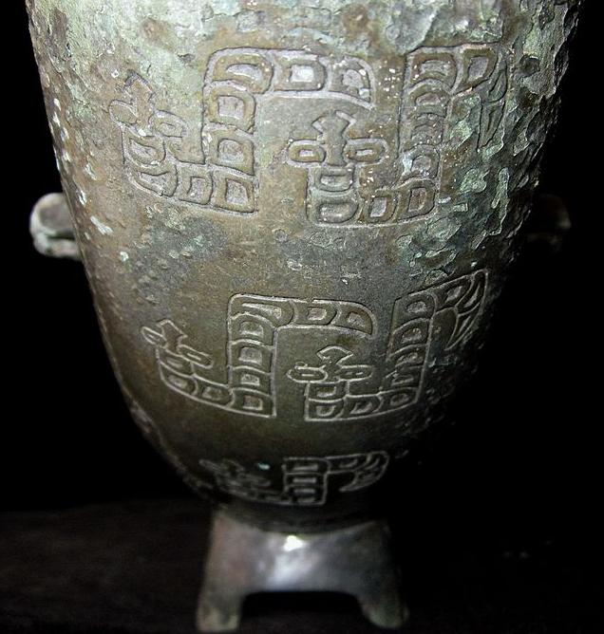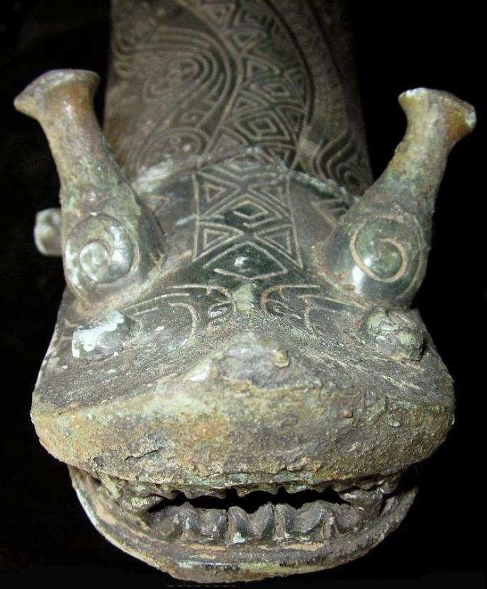
View of snout and composite antler-horns: bottle-shaped muntjak deer antlers with curved argali horns carved on them.
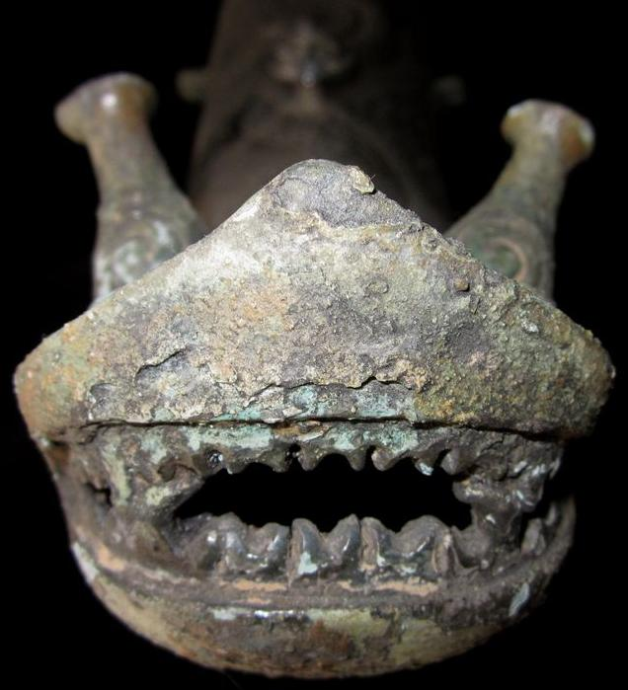
Shark-like snout with shark-like teeth.
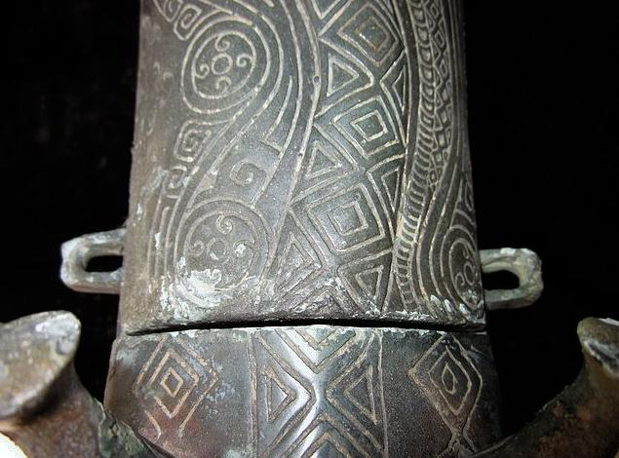
Composite curvilinear water motifs within circles and diamond patterned snake skin on dorsal ridge.
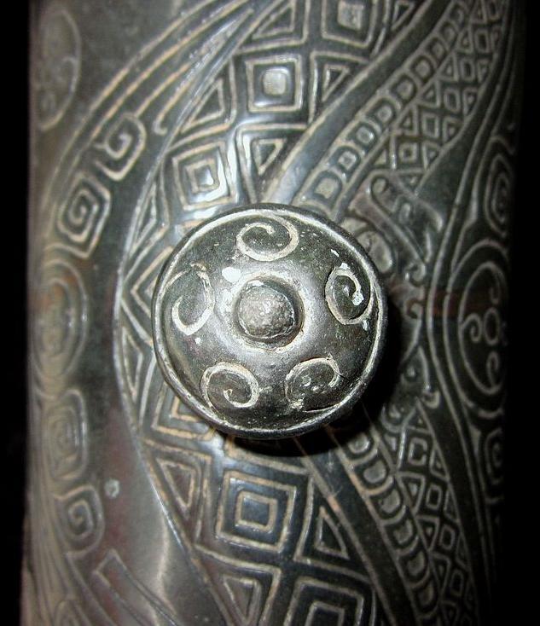
Water wave carvings on knob with diamond snake-skin pattern on lid.
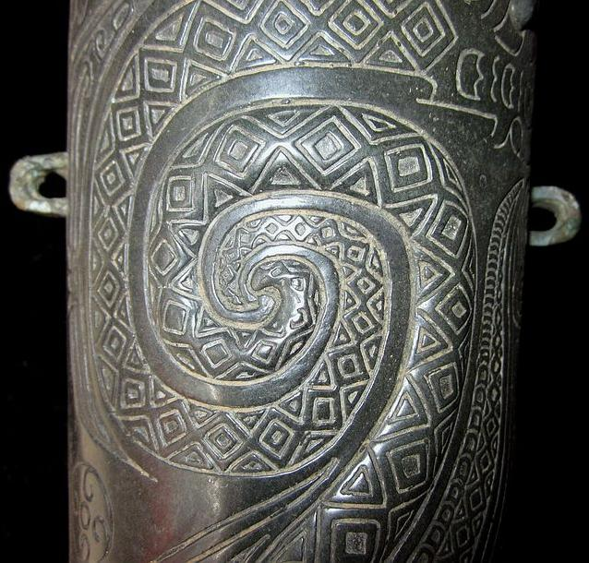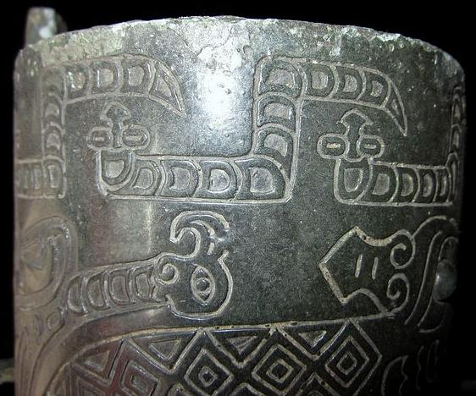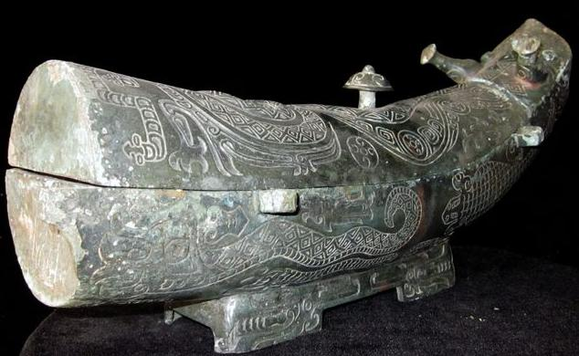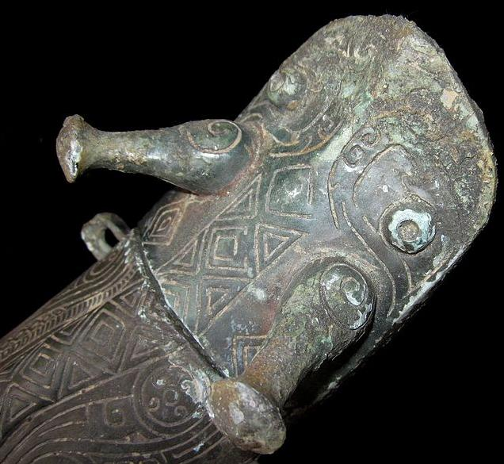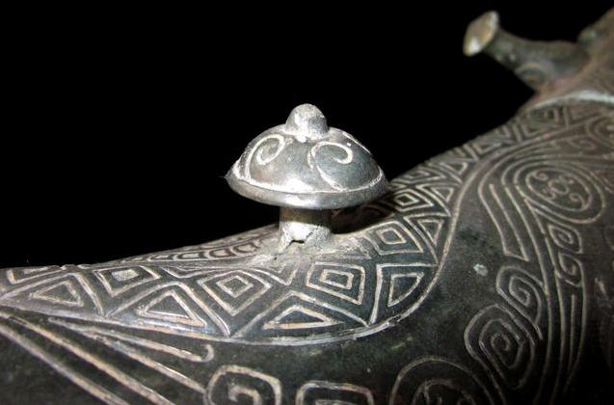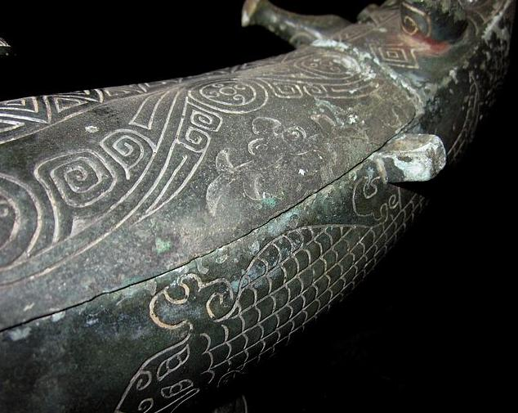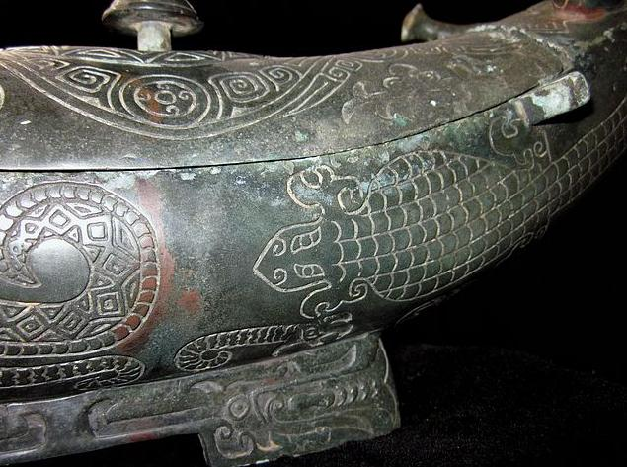

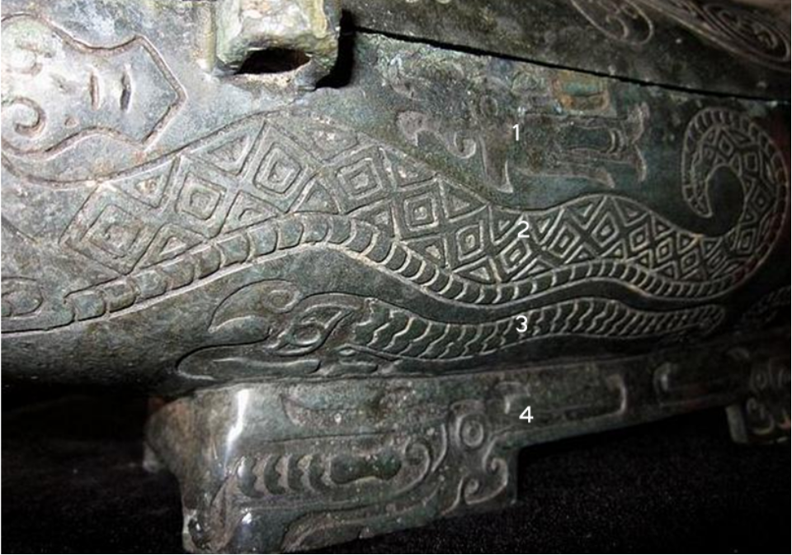
Engraved 1. grouper type fish with a wide mouth, 2. possibly a river python, 3. perhaps a giant squid and 4. possibly an alligator.
. 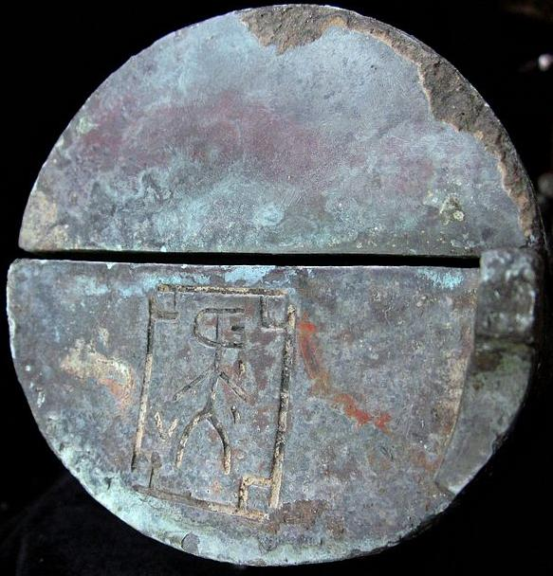
The bronze sculptor’s personal hallmark
Credible Antique,very rare. Bronze Wine Ware Pot GONG.Dragon Statues on the body.Beautiful color with proper size. CONDITION:Rust on the body, museum quality
Case No.:
Accession Number:
Formal Label:
Display Description:
This Shang bronze gong depicts a composite dragon made of the combined sculptured motifs of the body of an alligator (Alligator sinensis), the antlers of a muntjak, the teeth of a shark, and the engraved images of taotie images of apotropaic animal protectors, and "hooked cloud" motifs and fire symbols on its antlers. Alligator sinensis. had emigrated west via the Bering land bridge during one of the glacial maxima and had settled in southern China. It was an isolated species that had crocodile cousins in the verdant swamps of Vietnam and Cambodia. This Chinese alligator although diminutive in size when compared with its New World relative captured the imagination of expert jade sculptors.

The reason for this fascination with the Chinese composite dragon was that in Shang China there was a belief that the appearance of dragons brings about rain. Was there any truth to this belief? It was certainly a question that was being asked in the Confucian era when the rationalist critic Wang Ch'ung (27-100 CE) acceded to the existence of unexplained phenomena in the Lun-heng (論衡, "Discourse balance" ca. 80 CE, a compilation of critical essays on natural science, Chinese mythology, philosophy, and literature. So it may be affirmed that by this date the dragon principle was rationally accepted as verified by the latest scientific methods available.

When reference is made to the alligator in Chinese sources, the reference is to the one genus of Chinese Crocodilia, Alligator sinensis (揚子鱷, yáng zǐ è) and not to the crocodile, (subfamily Crocodylinae) or true crocodiles, large aquatic tetrapods that live throughout the tropics in Africa, Asia (exclusive of China), the Americas and Australia. The Crocodilia (or Crocodylia) is the Latin order of large, predatory, semi-aquatic reptiles that appeared 83.5 million years ago in the Late Cretaceous period. Crocodilia are the closest living relatives of birds and both are the only known survivors of the Archosauria, that also includes all extinct dinosaurs, extinct crocodilian relatives, and pterosaurs. There have been no true crocodiles in China.

Alligator sinensis is one of only two known living species of Alligator, which is now native only to the lower reaches of the Yangtze River, along Yijiang and Taihu river-basin swamps and in the provinces of Jiangsu, Zhejiang, and Anhui. However, in the past its range was throughout most of southern China.
INCLUDEPICTURE "C:\\Users\\murcott\\Documents\\Application Data\\Microsoft\\`2013 Nov 12-29\\Local Settings\\Temp\\scl30.jpg" \* MERGEFORMATINET INCLUDEPICTURE "D:\\..\\Application Data\\Microsoft\\`2013 Nov 12-29\\Local Settings\\Temp\\scl30.jpg" \* MERGEFORMATINET 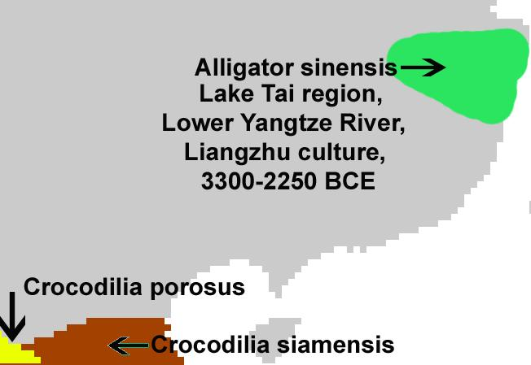
Range of Alligator sinensis coinciding with the jade-working, Neolithic, Liangzhu Culture, ca. 3300-2250 BCE.

Unlike its cousin, the American alligator, the Chinese alligator is armored over its entire body a feature of only a few Crocodilia, the order of large reptiles dating back 83.5 million years and named for the so called "pebble-worm" (κροκόδειλος Greek) texture of its body scales, which resembles the later Chinese Bronze Age Shang moiré pattern of curvilinear spirals that fills the interstitial surfaces on ritual bronze vessels. Hence we may infer that the Shang use of this artistic motif is related to Alligator sinensis as the archetypal embodiment of the Chinese concept of dragon, as most of the Shang bronze animal containers representative of mythical animals and dragons have this imagery emblazoned over their bodies.
INCLUDEPICTURE "C:\\Users\\murcott\\Documents\\Application Data\\Microsoft\\`2013 Nov 12-29\\Local Settings\\Temp\\scl10.jpg" \* MERGEFORMATINET INCLUDEPICTURE "D:\\..\\Application Data\\Microsoft\\`2013 Nov 12-29\\Local Settings\\Temp\\scl10.jpg" \* MERGEFORMATINET 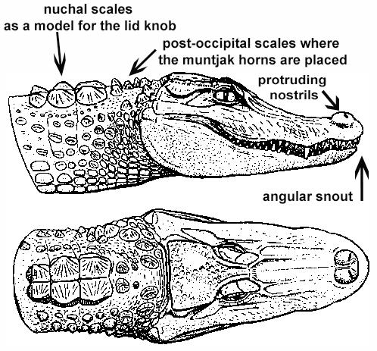
Alligator sinensis after Wermuth & Fuchs (1978)
In fact, this was from a biological and ecological point-of-view entirely reasonable. The Chinese alligators appeared when the monsoonal rains first inundated the patties: this was the harbinger of rice fructification, as the alligators scrambled up the slopes to secure a nesting site to lay their eggs that required access to at least 5 hours of sunlight each day as the females do not incubate their young.
The Monsoon as the Dragon's Time
The monsoon is a seasonal reversal of air currents accompanied by corresponding changes in precipitation (Ramage 1971). This is a seasonal change in atmospheric circulation and precipitation associated with the asymmetric heating of land and sea (Trenberth, Stepaniak, Caron 2000). Traditionally, "monsoon" refers to the rainy phase of a seasonally-changing pattern of which its alternative is a dry phase. Over oceans, the air temperature remains relatively stable for two reasons: because water has a relatively high specific heat (3.9 to 4.19 J g⁻¹ K⁻¹) (http://www.engineeringtoolbox.com/specific-heat-fluids-d_151.html), and because both conduction and convection will equilibrate a hot or cold surface with deeper water (up to 50 m.). In contrast, dirt, sand, and rocks have a lower specific heat (0.19 to 0.35 J g⁻¹ K⁻¹) (http://www.engineeringtoolbox.com/specific-heat-solids-d_154.html), which can only transmit heat into the earth by conduction and not by convection. Therefore, bodies of water stay at a more even temperature, while land temperature is more variable.
During warmer months sunlight heats the surfaces of both land and oceans, but land temperatures rise more quickly because it has a lower specific heat. As the land's surface becomes warmer, the air above it expands and an area of low pressure develops. Meanwhile, the ocean water which has a higher specific heat remains at a lower temperature than the land, and the air above it retains a higher pressure. This difference in pressure (lower over land and higher over water) causes sea breezes to flow from the ocean to the land, bringing moist air inland. This moist air rises to a higher altitude over land and then it flows back toward the ocean (thus completing the cycle). However, when the air rises, and while it is still over the land, the air cools with the higher elevation it attains. This decreases the air's ability to hold water, and this causes precipitation over the land. This is why summer monsoons cause so much rain over land.

This unique depiction of a late Neolithic jade alligator from the Liangzhu Culture (3300-2250 BCE) has portrays the denizen of the watery deep in white jade. This jade alligator has motifs carved on its surface that relate to both the heavens (curvilinear moiré spirals as cloud motifs) and to water (reptilian motifs, suggestively alligators) and. The coincidence of this imagery of heavens and water suggests the ecological demands of Neolithic agriculture in China: the need for water as predicted from the seasonal monsoonal season when the rains would ensue to ensure a productive harvest.
The moiré pattern of curvilinear spirals on Neolithic jade cloud motifs and on Shang Dynasty bronze vessels have this image of a cyclic pattern associated with the swirling clouds in the sky world of meditating shamans.
A description of an entire ritual to invoke rain is included in the Ch'un-ch'iu fan-lu by Tung Chung-shu. It was in this ritual that the alligator held a prominent place for the alligator was the repository of the sacred libation that could invoke the composite dragon spirit and usher in the monsoonal rains.

LC Classification: NK5750

Date or Time Horizon: 1500 BCE
Geographical Area:
Map:
GPS Coordinates:
Cultural Affiliation:
Medium:
Dimensions L 38CM/14.96 in, H 17CM/6.69 in
Weight:
Provenance:
Condition:
Discussion:
References:

Appendix


